**Introductory Physics Hunter College**

**Accelerated Motion**

**Objectives**

To explore accelerated motion.

**Background**

Acceleration is the rate of change of velocity.

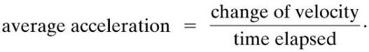

Even though acceleration may vary like velocity and displacement, assume all accelerations in this lab are constant.

Acceleration is a vector, although in one-dimensional motion we only need the sign.

For constant acceleration

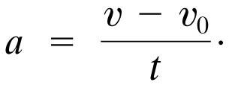 eq 1.

The velocity and position can be determined to be:

 eq. 2

eq. 3

The most common examples of motion with constant acceleration is a freely falling body. Near the surface of the Earth, all objects experience approximately the same acceleration due to gravity. The acceleration due to gravity at the Earth’s surface is approximately 9.80 m/s2. In the absence of air resistance, all objects fall with the same acceleration, as the coin and feather in the image below.

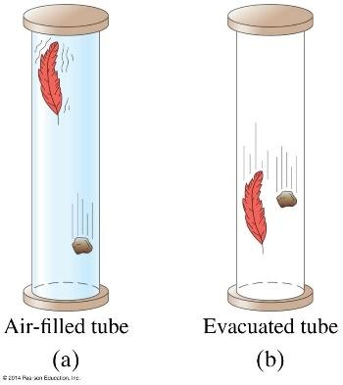

**Pre-Lab Questions**

1. If the velocity of an object is zero, does it mean that the acceleration is zero? Give an example of how this is possible.
2. If the acceleration is zero, does it mean that the velocity is zero? Give an example of how this is possible.
3. At time t = 0 an object is traveling to the right along the +x-axis at a speed of 10m/s with acceleration a = -2.0m/s2. Which statement is true?
4. The object will slow down, eventually coming to a complete stop.
5. The object cannot have a negative acceleration and be moving to the right.
6. The object will continue to move to the right, slowing down but never coming to a complete stop.
7. The object will slow down, momentarily stopping, then pick up speed moving to the left.
8. At t = 7 s, what is the displacement and velocity from question 3.

**Procedures**

**Constant Accelerated Motion**

1. Openthe simulation Constant acceleration, same physics simulation <http://physics.bu.edu/~duffy/HTML5/constant_acceleration.html>

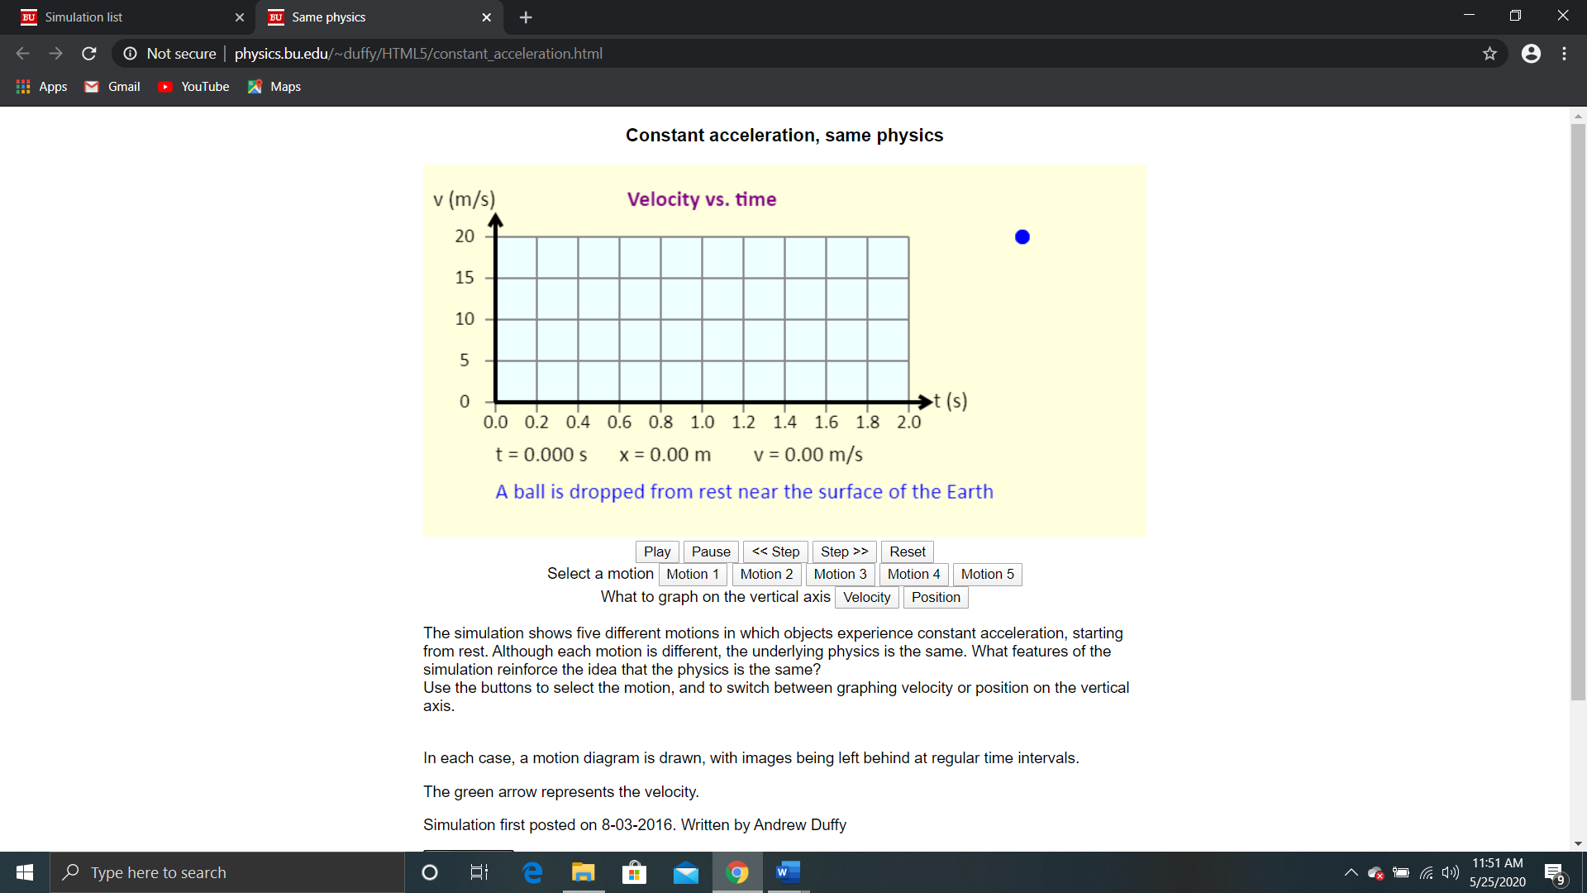

1. In this simulation you will explore 5 different types of motion; see the figure above.
2. For each motion a graph will be created to indicate position and velocity over time.
3. Explore the control tabs. The Play tab runs the simulation. The Pause tab stops the simulation during the run. You may forward and reverse the simulation in small time
4. increments to see specific points in time. The Reset tab clears the simulation to restart.
5. Select the first motion by clicking the Motion 1 tab and click the Velocity tab.
6. Play the simulation.
7. The first row of the Motion table should match your observations and calculation of the velocity vs time graph.
8. Now switch the from the “Velocity” tab to the “Position” tab and Play the simulation.
9. The first row of Table 1 should continue to match your observation and calculation.
10. Repeat steps 5 – 9 for Motions 2 – 5 and complete Table 1 for Motions 2 - 5.

|  |  |  |  |  |  |
| --- | --- | --- | --- | --- | --- |
| Table 1: Motion | | | | | |
| Motion | Velocity Direction | Acceleration  Direction | Calculated Acceleration  a = Δ**v**/Δt | Displacement Direction | Calculated Displacement  Δx = vot +(1/2)at2 |
| 1 | -y-axis | -y-axis | 10 m/s2 | -y-axis | 20 m |
| 2 | -y-axis |  |  | -y-axis |  |
| 3 | +x-axis |  |  | +x-axis |  |
| 4 | +x-axis |  |  | +x-axis |  |
| 5 | +x-axis |  |  | +x-axis |  |

1. Based on your observations for the 5 motion simulations, are the positions and velocities in the same directions of the accelerations, or in the opposite directions of the accelerations?
2. Note that it appears that the velocity is positive for motion one and motion two. Sketch a graph for the true velocity over time as the ball is falling for Motion 1.
3. Is it correct for all motion that vectors of displacement, velocity, and acceleration always point in the same direction? Explain.

**Drawing any grap**h: This lab provides screen shots of various graph templates in which you are asked to draw a line or curve. Because of differing software capabilities, please determine for your own system, the best way to exhibit the graph you created.

If you are limited in your capabilities, feel free to use the small screenshots provided here.

**Free Fall (acceleration = g (9.8m/s2))**

You will explore how will the position and velocity of an object falling from rest change under the influence of gravity, neglecting air resistance.

1. How long will it take for the ball to fall 20 m, from rest, under the influence of gravity; neglect air resistance. Show your calculation.
2. Sketch how position of the falling object will change over time. You may sketch on the blank position vs time graph, or by any means you can.

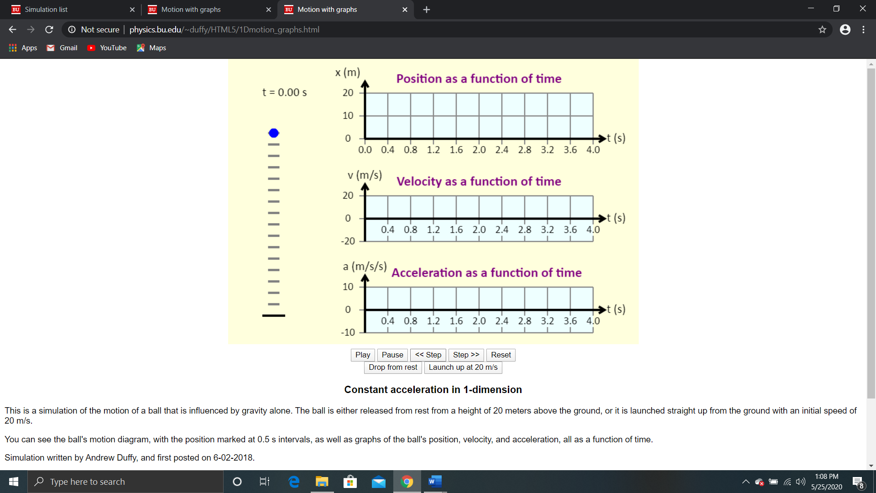

1. How fast the ball is the ball moving will be, just as it hits the ground. Show your calculation.
2. Sketch how velocity will change over time. You may sketch on the blank velocity vs time graph, or by any means you can.



1. Now, sketch how acceleration will change over time. Sketch your results below. You may sketch on the blank acceleration vs time graph, or by any means you can.



1. Now, go to the simulation: <http://physics.bu.edu/~duffy/HTML5/1Dmotion_graphs.html>
2. When you open the simulation, it may be running. Click Pause, Reset, “Drop from rest”, and Play to examine the graphs that represent free fall. Note that the Step>> and <<Step controls allow you to closely examine the values at various times.
3. Compare your sketches with the simulated graphs. How reasonable were your predictions?
4. According to the simulation graphs, in what direction is the acceleration?

We will now explore how the position and velocity change when an object is launched vertically at 20 m/s from the ground, y = 0m, under the influence of gravity, neglecting air resistance.



1. How long will it take for the ball to be launched vertically at 20 m/s, from the ground and return to the ground, under the influence of gravity; neglect air resistance. Show your calculation.
2. How high does the ball reach? Show your calculation.
3. Sketch a prediction about how position will change over time. Sketch your results below. You may sketch on the blank position vs time graph, or by any means you can.



1. Sketch a prediction about how velocity will change over time. Sketch your results below. You may sketch on the blank velocity vs time graph, or by any means you can.
2. Sketch how acceleration will chang over time. Sketch your results below. You may sketch on the blank acceleration vs time graph, or by any means you can.



1. You are going to return to the simulation. When you do click the tab “Launch up at 20 m/s”.
2. From the graph, estimate how long it takes for the ball to reach the ground again and compare it to your calculated value, i.e. calculate the percent error.
3. From the graph, estimate the maximum height of the ball and compare it to your calculation, i.e. calculate the percent error.
4. Compare your velocity vs time sketch with the simulated velocity vs time graph. How good was your prediction and explain?
5. When the ball is dropped from 20 m to the ground compare the average speed to the average velocity?
6. When the ball is launched vertically at 20 m/s and then falls to the ground compare the average speed to the average velocity.
7. Compare the values of speed and velocity for dropped verses the launched object and explain how those pairs of values are different.

**Post-Lab Questions**

Go to the Ranking Acceleration simulation, <http://physics.bu.edu/~duffy/HTML5/ranking_acceleration.html>,

1. Complete the ranking exercise. Take a screenshot of your completed exercise.

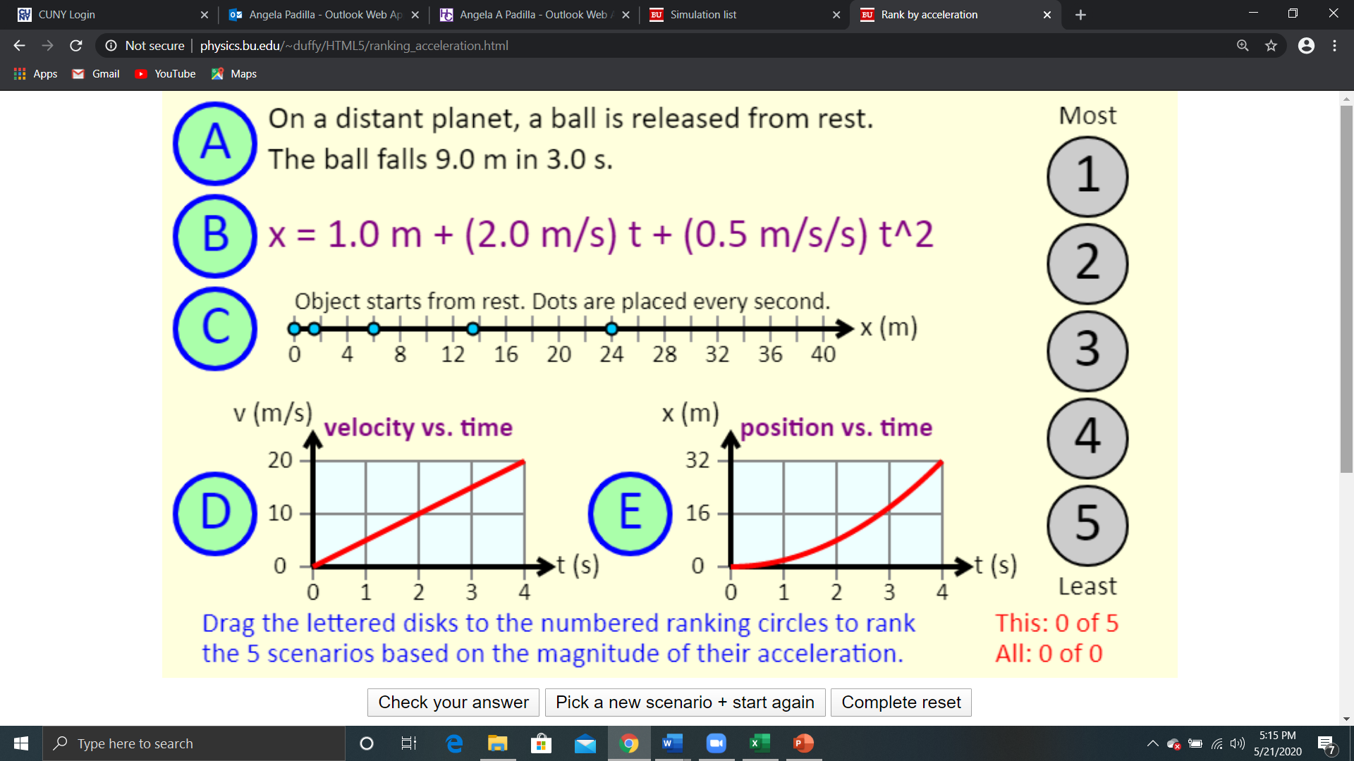

1. The position *x*(*t*) of a particle as a function of time *t* is given by the equation *x*(*t*) = (3.5 m/s)*t* - (5.0 m/s2)*t*2. What is the average velocity of the particle between *t* = 0.30 s and *t* = 0.40 s?
2. The captain orders his starship to accelerate from rest at a rate of "1 *g*" (1 *g* = 9.8 m/s2). How many days does it take the starship to reach 10% the speed of light? (Light travels at 3.0 × 108 m/s.)
3. The figure shows a graph of the velocity of an object as a function of time. What is the acceleration of the object at the following times?

(a) At 1.0 s

(b) At 3.0 s

(c) At 5.0 s

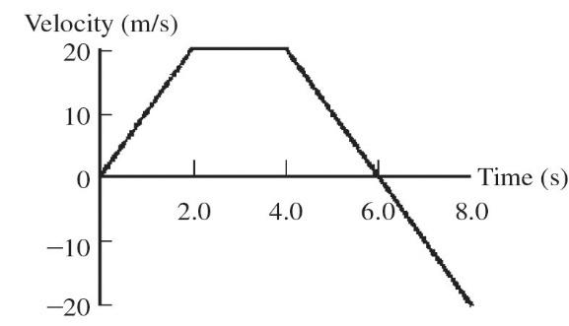

1. The graph in the figure shows the velocity of a particle as it travels along the *x*-axis. (a) In what direction (+*x* or -*x*) is the acceleration at *t* = 0.5 s?

(b) In what direction (+*x* or -*x*) is the acceleration at *t* = 3.0 s?

(c) What is the average acceleration of the particle between *t* = 2.0 s and *t* = 4.0 s?

(d) At what value of *t* is the instantaneous acceleration equal to 0 m/s2?

