**INTRODUCTORY PHYSICS HUNTER COLLEGE**

**WORK AND ENERGY**

You are encouraged to review the chapter on Energy from the Giancoli Physics textbook. There are many YouTube videos that discuss this topic. Four online sources are listed below:

<https://www.youtube.com/watch?v=AnuLW0ZX7-Q>

<https://www.youtube.com/watch?v=hce4pncZlI4&t=445s>

<https://www.youtube.com/watch?v=AzXb63GEMss>

<https://www.physicsclassroom.com/class/energy>

**Background**

Mechanical energy is the sum of the potential and kinetic energies in a system. The principle of the conservation of mechanical energy states that the total mechanical energy in a system (i.e., the sum of the potential plus kinetic energies) remains constant as long as the only forces acting are conservative forces. Normally, all forces acting on our system are conservative as long as there is **no friction**.

**Types of mechanical energy**

In mechanics problems, we are likely to encounter systems containing kinetic energy

$KE=\frac{1}{2}mV^{2}$ (1)

where *m* is the mass of our object and *V* is its speed (disregarding of the direction). Generally speaking, the kinetic energy is the energy of the motion and it disappears if the speed of our object is zero.

We will also often encounter gravitational potential energy

$PE_{g}=mgh$ (2)

where *h* is the elevation of our object from a fixed zero level. Only the vertical component, or

the height of our object contributed to its gravitational potential energy, not its horizontal position.

We might also need to account for the elastic spring potential energy of a compressed or stretched spring with spring constant *k*

$PE_{s}=\frac{1}{2}kx^{2}$ (3)

where *x* is the displacement of the end of the spring from its equilibrium position. Other types of potential energy include electrostatic potential energy, chemical potential energy, and nuclear potential energy. This exercise’s procedures will focus on the two types of mechanical energy, potential energy and kinetic energy.

**Conservation of the mechanical energy**

As we mentioned above, the mechanical energy is conserved if the friction forces acting on our system are negligible. Let us consider a cart moving along a frictionless track, as shown in Fig. 1

... 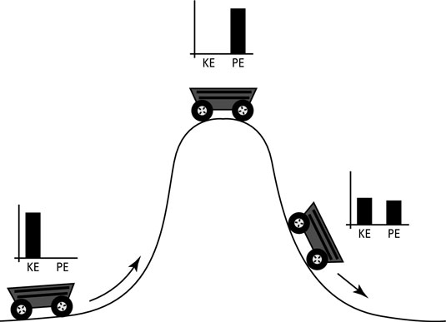

Figure 1: Conservation of mechanical energy (potential + kinetic) on a track. The bar charts show the amount of the potential and kinetic energies in different points of the track.

Its potential energy $PE_{g}=mgh$ depends only on its vertical position *h* along the track. If the total energy is conserved

$PE\left(h\right)+ KE\left(v\right)= E_{tot} = const. (4)$

the kinetic of the cart could be found as

$KE = E_{tot}-mgh$ (5)

where the total energy of the cart is equal to its potential energy at the highest point, where the cart is not moving and, therefore, its kinetic energy is zero

$Etot = PE(h_{max}) = mgh_{max}$ (6)

Once the kinetic energy *KE* of our cart is known, its speed could be found from the definition of kinetic energy as

$v=\sqrt{\frac{2KE}{m}}$（7）

If the energy is conserved, the potential energy is transferred to the kinetic and back so that the

potential energy in the lowest point of the track is zero, and the total energy is equal to the potential one.

If the friction force is present, the work of friction is negative and proportional to the distance which our cart has traveled along the track

$W_{f}=fd cosπ=-fd$

where *f* is the friction force. The total energy keeps constantly decreasing while our cart is moving along the track until it comes to a full stop.

**Pre-lab questions**

1. In a tug of war, one team is slowly giving way to the other. Describe the work done by the winning team and the work done by the losing team.

2. A projectile is fired with an initial velocity $v_{i}= 40 m/s$ at an angle 300 to the horizontal. What is its potential and kinetic energy after *t* = 1.8 second? Assume no friction.

3. A running man has 1/3 of the kinetic energy that a running boy of 2/3 of his mass has. If the man speeds up by 1 m/s, their kinetic energies will become equal to each other. What are the speeds and kinetic energies of the man and the boy?

**Procedure**

1. Open the Energy Skate Park simulation

<https://phet.colorado.edu/sims/html/energy-skate-park-basics/latest/energy-skate-park-basics_en.html>

1. Choose the Intro tab on the left . Your screen should look like this.

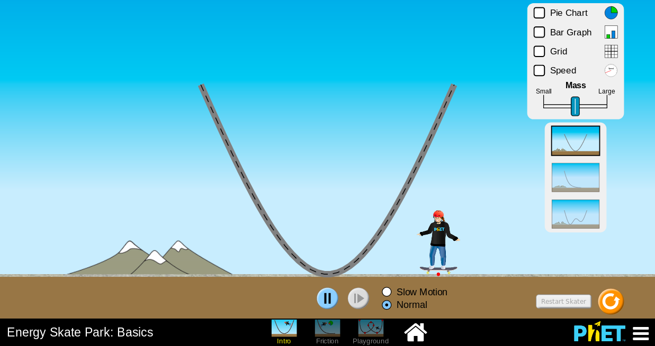

1. Set the mass of the skater to the lowest value by sliding the Mass control all the way to the left 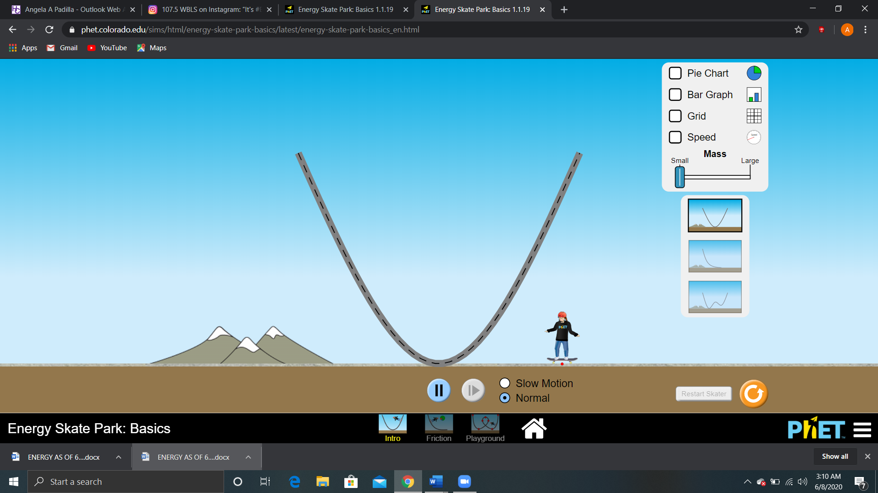.
2. Click and drag the skater to place him on the highest point on the left side of the track.
3. Now click the play button at the bottom center of the screen. The skater will demonstrate periodic motion along the track, up and down. Note that the red dot on the skateboard is the reference point for any position.
4. Sketch PE and KE on the same graph with height h on the x-axis and energies on the y-axis.

* *PE(h)* and kinetic energy *KE(h)* as skater descends on from the left
* *PE(h)* and kinetic energy *KE(h)* as the skater ascends to the right.

1. Enable all the checkmarks *Pie Chart, Bar Chart, Grid and Speed* in the top right corner of your screen, which will now look like this.

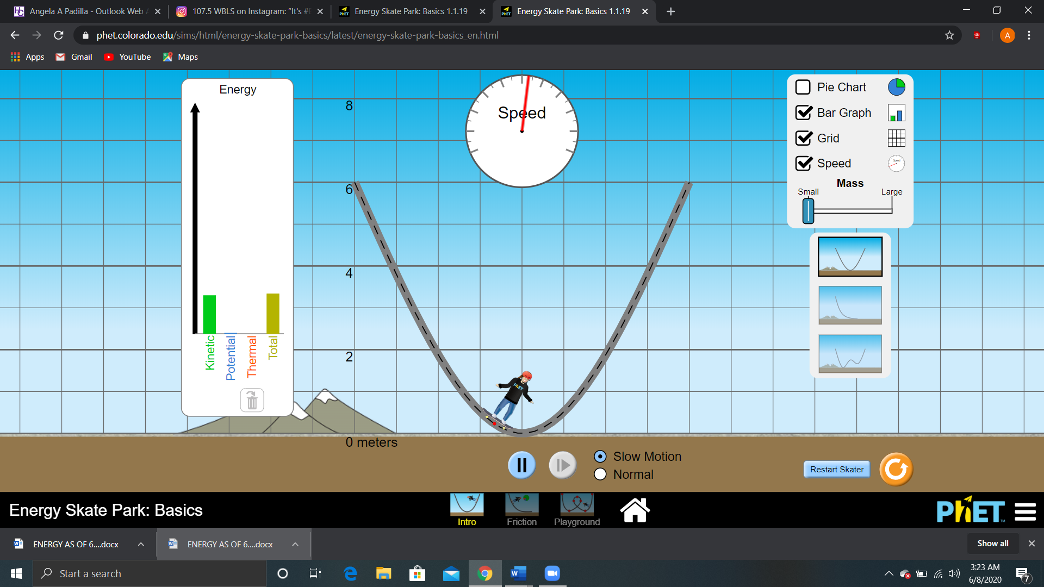

Figure 3:

1. How does the total mechanical energy change with time?

* How do you determine the Potential Energy *PE*?
* How would you determine the KE of the skater at any point where you would know h and the mass of the skater?

1. Let the mass of a skater to be *m1* = 30 *kg.* Calculate its potential energy at *h* = 6m, 5m, 4m, 3m, 2m 1m and 0 using Eq. 2, **for the left side of the track only**. Record your results in Table 1.

|  |  |  |  |  |  |  |  |
| --- | --- | --- | --- | --- | --- | --- | --- |
| Table 1. Potential energy of the skater as a function of his/her height on the track. | | | | | | | |
| *Height h (m)* | 6m | 5m | 4m | 3m | 2m | 1m | 0m |
| *PE= mgh (J)* |  |  |  |  |  |  |  |

1. How much should the total Mechanical Energy of this system be?
2. Based on the conservation of mechanical energy expressed in Eq. (5), determine the kinetic energy of the skater at points *h* = 6m, 5m, 4m, 3m, 2m 1m and 0, for the left side of the track only, and record your results in the top row of Table 2, below.
3. Then determine the speeds of the skater using the KE equation # 7 at each height. Record the results in the second row of Table 2.
4. Now using the pause and step controls of the simulation record the speed indicated by the round speedometer. Each division on the speedometer represents one meter per second from 0 to 20m/s. Enter values closest to the nearest 0.5 m/s. Record the values in the bottom row. Again, only use the left side of the track.
5. How close were the two rows of speed?

|  |  |  |  |  |  |  |  |
| --- | --- | --- | --- | --- | --- | --- | --- |
| Table 2. Kinetic energy and velocity of the skater as a function of his/her height on the track. | | | | | | | |
| *Height h [m]* | 6m | 5m | 4m | 3m | 2m | 1m | 0m |
| *KE(h) [J]*  *ME-PE* |  |  |  |  |  |  |  |
| *V [m/s]*  *Calculated* |  |  |  |  |  |  |  |
| *V [m/s]*  *Speedometer* |  |  |  |  |  |  |  |

1. How closely do the values of the calculated and recorded speed match?
2. Add up the total values of the 6 speeds for the calculated and speedometer values. Find the percent difference between them.

Abs{}

------------------------------ x 100%

$ΣVspeed.$

1. Now using the data from Tables 1 and 2, plot *PE*, *KE* and Total energy, *Etot* on the same graph vs. position h, at the heights of 6m,5m,4m,3m,2m,1m, and 0m. Put height on the x-axis and energies on the y-axis. Use the red dot on the skateboard to guide you to the appropriate height. Clearly indicate which energy each line represents.
2. By freehand try to draw a line of best fit. Remember it may not be a straight line. Also, the line of best fit does not have to touch all the plotted points. How do these graphs compare to the first half of the sketches you originally made in Step 6, when the skater descends?
3. Now slide the Mass lever to the right to obtain the greatest mass.
4. Play the simulation.
5. Record the speed of the speedometer at heights of 6m, 5m, 4m, 3m, 2m, 1m and 0m in Table 3.

|  |  |  |  |  |  |  |  |
| --- | --- | --- | --- | --- | --- | --- | --- |
| Table 3. Speed of the Large Mass Skater | | | | | | | |
| *Height h [m]* | 6m | 5m | 4m | 3m | 2m | 1m | 0m |
| *Vexp， m/s*  *Large Mass* |  |  |  |  |  |  |  |

1. How does the speeds for the larger mass skater compare with the lower mass skater?
2. Now let’s explore motion on a different track; see track options on the lower right of the screen.
3. Select the track with two dips  by clicking on it.
4. Set the mass of the skater to the smallest value.
5. Place the skater on the left highest point.
6. Play the simulation with the Slow-Motion option and observe the speed variations on the speedometer.
7. As the speed changes, describe the patterns of changes in PE, KE and Etot.
8. Now record the speedometer's speed of the skater at heights of 2 m, on the left of the hill, at the hill, and to the right of the hill. Note: Use the Pause and Forward buttons to attain the desired positions.

|  |  |  |
| --- | --- | --- |
| Table 4. Speed of the Skater at a height of 2 m | | |
| Left of hill, h = 2m | At the hill, h = 2m | Right of hill, h = 2m |
| Speed v = | Speed v = | Speed v = |

1. What can you conclude about the data you just recorded?

1. Explain how the total energy and speed of the skater changes with time in the presence of friction.
2. Click on the Friction window at the bottom of your screen 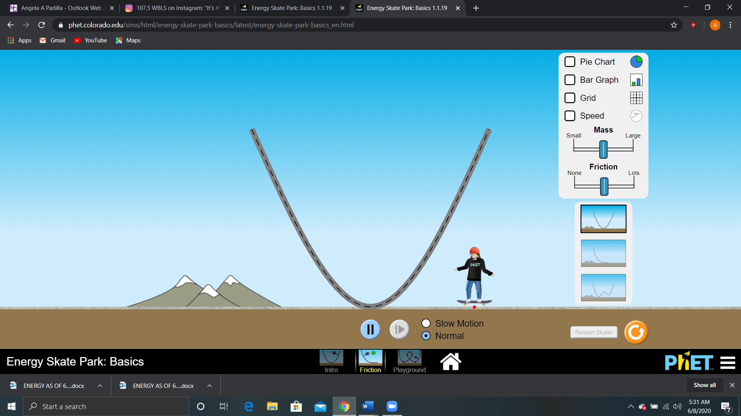.
3. Select all the options for grid, speed, bar graph, and pie chart.
4. Set the mass to the minimum value and friction at the middle value.
5. Let the mass of the skater be 30 kg, play the simulation and observe the skater.
6. Describe how the mechanical energy of the skater changes over time.
7. Now, press the Pause tab and return the skater to the top left of the track.
8. Using the forward button, record 6 speeds from the speedometer of the skater from start to finish in Table 5. Choose points where you can identify the speed and the heights fairly accurately, either from the left or right side of the track. The first point must be at the start of the motion and the last data point must be when the skater comes to a complete stop. The first and last entries are already entered in the table.
9. Complete Table 5 by calculating the PE, KE, and Total Mechanical Energy of the Skater.

|  |  |  |  |  |  |
| --- | --- | --- | --- | --- | --- |
| Table 5. Mechanical Energy of the Skater w/Friction | | | | | |
| Time | Height m | Speed m/s | PE | KE | Emech-tot |
| T1 | 6m | 0 m/s |  |  |  |
| T2 |  |  |  |  |  |
| T3 |  |  |  |  |  |
| T4 |  |  |  |  |  |
| T5 |  |  |  |  |  |
| T6 |  |  |  |  |  |
| T7 |  |  |  |  |  |
| T8 | 0m | 0 m/s |  |  |  |

1. How much total Mechanical Energy of this system start off with? Show your calculation.
2. How much total Mechanical Energy was lost by the end of the skater’s motion? Why?
3. Does the loss of Mechanical Energy violate the Law of Conservation of Energy? Explain.
4. Plot the energy loss due to friction and total mechanical energy on the same graph vs time; use T1 – T8 as your times, from Table 5. So, instead of having specific times in seconds your x-axis will just state T1, T2, T3, etc.
5. According to your graph, how much thermal energy was gained by the system?
6. Where did the thermal energy come from?
7. Based on your results, what can you conclude about the change of the total energy of the system over time in the presence of friction? Explain.